Battle of the Books 2024-2025

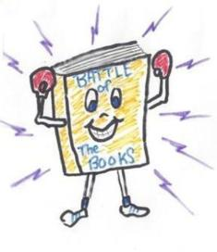

A. K. Suter will participate in the Battle of the Books again this year. Battle of the Books is a reading competition for 3rd through 5th graders based on the Sunshine State Young Reader Award (SSYRA) books. The books are on the back of this sheet and listed on the library page of our school website.

The format for the competition is much like the Sunshine Math Competition. Team members will work together to choose the correct answer for the questions. All team members will participate in all of the rounds. Winners will be announced at the end of the competition. The District Battle of the Books competition is tentatively scheduled for Saturday, April 26th at Washington High School between 7:30 am and 11:00 am.

We are looking forward to another great year! However, we can only have three teams with a maximum of five members per team. If your child is interested in participating in this year’s Battle of the Books and will be available Saturday morning, April 26th, please return the form below to receive detailed information about the selection process.

If you would like more information about the Battle of the Books competition, please visit the district website: <https://www.escambiaschools.org/Page/1019>

Thank you for your interest!

Mrs. Stillman

Student’s Name: ____________________________________________________________

Grade Level: __________ Homeroom Teacher: ________________________________

My child is interested in participating in the Battle of the Books competition.

We are available Saturday morning, April 26th, 2025.